

Software Design & Implementation
Project Report


Project Manager – Richard Stone N0782914
Software Architect – Thomas Harrison N0833220
Software Developer – Samuel Harrison N0787108
Software Tester – Stephen Anderson N0786072

Lab Tutor – Pedro Machado

Abstract

Revision History

Table 1 - Revision History
Version | Issue Date | Stage | Changes | Author
0.0.1 | 20/02/20 | Alpha | Added basic Windows Forms Functionality, GUI, and basic file handling. | Samuel Harrison
0.0.2 | 24/02/20 | Alpha | Improved image padding/centring and general GUI fixes. | Samuel Harrison
0.1.0 | 01/03/20 | Beta | Added images being loaded to a list in the left side of the GUI, implemented basic annotation drawing, separated into headers and source files. | Samuel Harrison
0.1.1 | 01/03/20 | Beta | Added the test plan and added the test framework to the project with stub definitions. | Stephen Anderson
0.1.2 | 29/3/20 | Beta | Added more headers, attempting to resolve an issue where test framework would not work. | Samuel Harrison
0.2.0 | 04/04/20 | Beta | GUI updates, added the ability to click and drag to create annotations, added the ability to load a .names file for annotation classes. Added remove annotation button. | Samuel Harrison
0.3.0 | 05/04/20 | Beta | Added search functionality for images, classes, and annotations. | Samuel Harrison
0.3.5 | 06/04/20 | Beta | Added new .names files to be tested and made existing .names more appropriate. | Richard Stone
0.3.6 | 06/04/20 | Beta | Restructuring of the project in an attempt to fix test framework issues. | Stephen Anderson
0.3.7 | 06/04/20 | Beta | Added more accurate header files, resolved conflicts. | Samuel Harrison
0.4.0 | 22/04/20 | Beta | Fixed threading issue by adding ‘[STAThread]’ to main.cpp. | Richard Stone
0.5.0 | 24/04/20 | Beta | Added JSON functionality. | Samuel Harrison
1.0.0 | 25/04/20 | Release | Fixed many GUI bugs, added sort functionality, added resizing, fixed linked list functionality allowing tests to be run. | Samuel Harrison
1.0.1 | 25/04/20 | Release | Completed unit tests. | Stephen Anderson

GitHub link: https://olympuss.ntu.ac.uk/N0786072/SDI-Project
Contents
Abstract 1
Revision History 2
Tables 6
Figures 7
Introduction 8
Background 8
Aims 8
Objectives 8
Background Research 9
Project Analysis 10
Requirements Analysis 10
Risk Assessment 14
Time Plans 17
Assumptions 18
Adopted Coding Standards 19
Coding Style Guide 19
Contribution Guide 26
Code of Conduct 26
Making contributions to the project 26
Reporting bugs and issues 26
Use Case Diagram 27
Class Diagram 28
Sequence Diagrams 29
State Diagram 30
Component Diagram 31
GUI Mock-up 32
Test Plan 33
Conclusions and Future Work 34
References 35
Individual Contributions Per Member 36
Overall Reflection of the Work Done 37
Appendix 38
Appendix 1 – Test Report 38
Appendix 2 – User Interface 39
Appendix 3 - Group Meetings 41
Plagiarism Declaration 43

Tables

Table 1 - Revision History 2
Table 2 Background Research 9
Table 3 Requirements Analysis 13
Table 4 List of Restrictions 16
Table 5 - Sample Test Table 33

Figures
Figure 1 Gantt Chart 17
Figure 2 Use Case Diagram 27
Figure 3 Class Diagram 28
Figure 4 Sequence Diagram for file handling Figure 5 Sequence diagram for annotation file manipulation 29
Figure 6 Sequence diagram for annotation manipulation 29
Figure 7 State Diagram 30
Figure 8 Component Diagram 31
Figure 9 GUI Mock-up 32
Figure 10 - Typical User Interface 39
Figure 11 - Including File Browsing 40

Introduction

Background
In the modern world of computing, artificial intelligence holds a great prominence with its range of uses and applications. Its primary purpose is to automate tasks in the same fashion as a human operator, increasing productivity while maintaining the same degree of precision. To achieve this functionality, a neural network may be implemented – this is a system which uses a set of sample data, called a dataset, to predict future results. Hirose (2013) discusses one such use in image processing; neural networks can be used to identify certain genes or organs in an MRI scan, for example, while Dybowski and Gant (2001) suggest the use of this technology to indicate the presence of diseases via ultrasound examination.
For a convolutional neural network to work, the dataset must first be built from data that has been manually collected. The objective of this project is to design a program that would streamline the process of building a dataset to be as simple and user-friendly as possible. Such a program would be highly applicable to the training of a convolutional neural network; labels would be used to define certain elements in an image, and a greater scope project would use this sample data to identify the same element in other data without manual input. In the case of Hirose’s application of neural networks in an MRI scan, the program could allow a user to indicate specific organs in a scan, allowing a larger system to recognise instances of that same organ in other images.
During this project, the group aims to enrich their knowledge of the creation and operation of neural networks, as well as improving team building and working together on a group project.

Aims
The group aims to create an annotation drawing program which will meet all of the requirements outlined in the analysis phase. The functionality of the program should be evident to the user very quickly, which will be achieved through the creation of an intuitive user interface which will be easy for a person to use and understand.
Objectives
For the project to succeed, all of the following criteria must be met:
- Create an application in which labels of various shapes can be added to an image.
- Save data about each annotation.
- Save data about the classes each annotation belongs to.
- Sort and search through annotations, images, and classes.
- Store data using linked lists and other necessary data structures.
- Manipulate already existing annotations (resize, delete)
- Provide a user-friendly interface.

Background Research

Tool | Purpose | Notes
Microsoft Visual Studio | IDE | The selected IDE used by the group. This is due to the group having the most experience using Visual Studio as an IDE.
Windows Forms  System.Collections.Generic  Systems.ComponentModel  Systems.Data  Systems.Drawing  Systems.Linq  Systems.Text  Systems.Threading.Tasks  System.Windows.Forms | GUI/Functionality | Uses the .NET framework. The vast majority of the program will be created using these tools, including the GUI and creation of annotations. These have been selected as the software developer has the most experience with these frameworks and libraries.
Common Language Runtime (CLR) & Common Language Infrastructure (CLI) | Implementation | CLI allows the integration of various programming languages on various machines in order to improve reliability. CLR is the common runtime for all .NET languages.
Microsoft Unit Testing Framework for C++ | Testing | Standard Visual Studio unit testing framework, this will be used on back-end testing and is written in C++.
GitHub | Version Control | Use of GitHub in order to keep track of updates and help the group identify where problems may have arisen. This also ensures that
Slack | Communication | Use of Slack in order to split communication into sections and allow for pinned items which may be important. The channels will be structured as such: general, planning, design, development, testing, announcements.
Doxygen | Documentation | Help to create reliable documentation quickly.
Table 2 Background Research

Project Analysis

Requirements Analysis

Requirement Number | Requirement Description | Implications | Tasks
1 | Must be able to open image files. | Will have to make use of file handling and using libraries to allow an image file to load into the interface. | T1/T4 Implement file handling to allow the user to load an image file into the interface.
2 | Must be able to open annotation files. | Will have to make use of file handling and using libraries to allow an annotation file to load into the interface. | T1/T4 Implement file handling to allow the user to load an annotation file into the interface.
3 | Must be able to close image files from the current session. | Will have to make use of file handling within the GUI to allow an image file to be closed without closing the current session. | T7 Implement GUI elements to allow the user to close an image file from the interface.
4 | Must be able to close an annotation file from the current session. | Will have to make use of file handling within the GUI to allow an annotation file to be closed without closing the current session. | T7 Implement GUI elements to allow the user to close an annotation file from the interface.
5 | Must be able to save an annotation file. | Make use of file handling to save the annotation file to the user’s local storage. | T4/T7 Implement GUI elements and file handling functionality to allow the user to save a file.
6 | Must be able to append to an existing annotation file. | Make use of file handling, ensure that the file’s previous contents are not deleted. | T4 Implement file handling functionality to allow the user to append a file.
7 | Should be a panel in the GUI which lists compatible image files. | Will have to create a method of file handling within the GUI. | T4/T7 Develop a portion of the UI dedicated to listing compatible file types.
8 | Must be able to sort annotation files by name or date. | Must be able to make use of both file handling and sorting algorithms. | T5 Create a suitable sorting algorithm for the files.
9 | Must be able to create annotations by drawing a rectangle, triangle, trapezium, or free form polygon with up to eight vertices. | Must use libraries and frameworks to create selection tools annotations and interact with the GUI using the mouse pointer. | T1/T2 Create necessary classes and functions for implementing annotations of various shape. Use appropriate data structures.
10 | Must be able to remove annotations in an intuitive way. | Must integrate well with the function of creating annotations and be cleared from the GUI, therefore will need to learn in-depth GUI handling. | T1/T2 Create necessary functions within classes for removing annotations from the interface and data structures.
11 | Must be able to edit annotations by increasing the size or moving vertices. | Make use of libraries to edit already made annotations, this must remove the original unedited annotation in favour of the new edited annotation. | T1/T2 Implement appropriate functions for editing annotations.
12 | Must be able to select each different shape to draw an annotation. | Must be able to select between a rectangle, triangle, trapezium, and free form with up to eight points. Make use of drawing libraries. | T7 Must implement functionality in the user interface to allow switching between different shapes in an intuitive way.
13 | Must be able to copy and paste annotations. | Must make use of suitable copy and paste integration with the application. | T7 Ensure that through conventional methods (ctrl+c, ctrl+v) the interface allows the user to copy and paste annotations.
14 | Must visualise the name of the class on top of the shape. | Must learn how to add labels to annotations. | T2/T3 Create a label which tells the user the name of the annotation’s class.
15 | Must be able to search for a particular annotation. | Will have to make use of a suitable search algorithm to search for an annotation. | T5 Select a suitable search algorithm for this task and implement the code for it.
16 | Must be able to sort all annotations by date and title. | Will have to make use of a suitable sorting algorithm to sort annotations. | T5 Select a suitable sorting algorithm and implement the code for it.
17 | Must be able to convert data to/from HDF5 file format. | Will have to make use of libraries for file conversion. | T4 Select suitable libraries for file conversion and implement the code for it.
18 | Must be able to store annotations in a suitable way, most likely linked lists. | Make use of data structures such as linked lists. | T3 Implement code to store annotations in a linked list.
19 | Data about each annotation must be stored. | Making use of file handling to store data of number of images, image file name, number of shapes per image. For each shape: shape type, Point_1(x,y), Point_N(x,y)... | T3 Store data about each annotation in an appropriate data structure, and then make use of file handling to save the information to the user’s storage device.
20 | Must be able to store images in a suitable way, most likely arrays. | Make use of data structures such as arrays. | T3 Implement code to store images in an array.
21 | Must provide a suitable and intuitive user interface. | Must select an appropriate GUI library/framework. | T7 Create a user interface which is simple to use and not overly verbose.
22 | Must be able to classify the annotations to group similar annotations. | Will need to have annotations created in groups and have them identifiable according to similar characteristics. | T2 Implement relevant architecture to allow for annotations to be grouped with other annotations
Table 3 Requirements Analysis

Risk Assessment

Risk | Likelihood (1 – Very Unlikely, 5 – Very Likely) | Impact (1 – Very Low, 5 – Very High) | Impact on Project | Mitigation Plan
A group member suspends their study | 2 | 4 | Group members suspending their study may lead to a vastly increased workload on other members. | Ensure that members are informed as early as possible, and that this information is passed onto the module leader.
Absence due to illness | 3 | 2 | Project time may be wasted, particularly if the absence is during a group meeting. | Ensure that the absent group member is fully briefed on any meetings or aspects of the process which may have been missed.
Allocated tasks are not completed, or not completed on time. | 3 | 5 | The project of the quality may be hindered due to rushed work, or the workload of other members may increase | Internal deadlines will be set, however work will be expected to be submitted to the project manager well before this deadline. The project manager will ask for frequent, measurable updates using yes/no questions. E.g., can the program do this yet. Github will be used to keep track of members’ contributions.
Lack of communication | 3++ | 4 | May lead to poorer quality of work or even incorrect work. | Frequent face-to-face meetings, and a group chat has been set up on WhatsApp in order to keep up with all members. Slack will also be used.
Poor time management | 4 | 5 | Not managing time effectively may lead to an incomplete project. | Measurable goals should be set according to the date, the project manager will frequently communicate with all members for updates.
Project Assumptions | 4 | 3 | Underestimating the difficulty of particular aspects may lead to an incomplete or rushed product. | Every aspect will be rigorously discussed and preferably researched to ensure that all members fully understand the difficulty of each aspect.
Technical Failure | 1 | 4 | Technical issues such as a computer shutting down may lead to a loss of work. | Ensuring that frequent local backups and cloud backups will be taken to vastly reduce the amount of work lost.
Merge Conflicts | 3 | 3 | Two developers attempting to commit changes to the same file at the same time may lead to loss of work. | Developers will communicate when they need to commit, and in the event that a merge conflict should happen, a commit will never be forced and instead will be merged through strong communication.
Member conflicts. | 3 | 3 | Excessive member conflicts and lack of consensus may slow down the development process or lead to unhappy developers possibly resulting in lower quality work. | The group will be democratic, if three out of four members agree, that will be taken as the consensus. If it is split fifty-fifty, further discussion will take place until the project manager decides. Compromise will be necessary.
Table 4 List of Restrictions

Time Plans

All stages will be committed to a GitHub repository where possible. Slack will be used for communication between members.

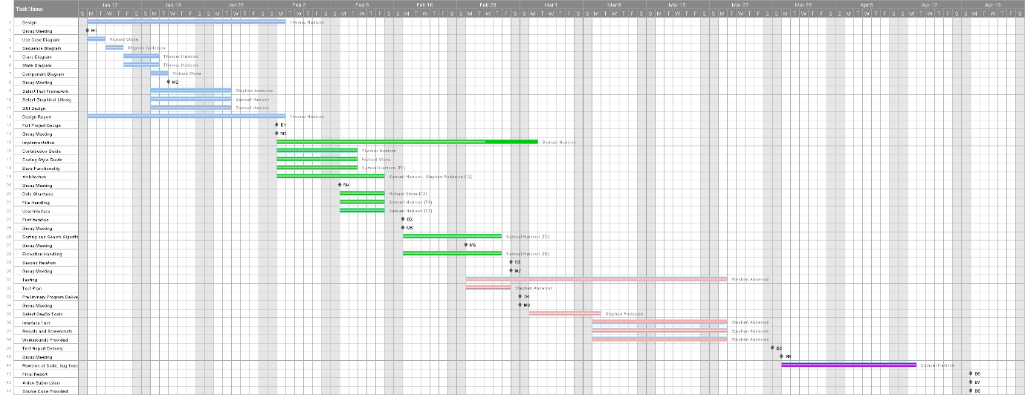
Figure 1 Gantt Chart

Assumptions

The group assumes that the user will have a computer running Windows 10 64 bit with at least semi modern hardware, this is necessary as Windows 10 is the only operating system which has been fully tested and the program may require more than 4GB of memory, which a 32 bit operating system will not support. The group also assumes that the user has a functional keyboard, mouse and monitor in order to interact with the user interface and allow full functionality of the program.

Adopted Coding Standards

Coding Style Guide

C++ Version
All code should be submitted using C++ 17, the latest version available.
Where possible, only standard libraries should be used, however due to the nature of this assignment graphical frameworks and test libraries from outside of the standard library will need to be used.

Header Files
Every .cpp file should have its own .h file, the .h file should contain declarations for classes and functions used in the associated .cpp file.
This improves the usability and modularity of the code.
Header files should compile on their own and therefore be self-contained. They should also end in .h for ease of understanding.

Order of Includes
Header files should be included in the following order: Related headers, C system headers, C++ standard library headers, other libraries’ header, this project’s header.
Separate each included header file type with a line. For example:
#include “relatedheader1.h”

#include <CSystemHeader1.h>
#include <CSystemHeader2.h>
#include <StdLibHeader1.h>
#include <StdLibHeader2.h>
#include “this/ProjectsHeader.h”

Scoping

Namespaces
Namespaces should be used to separate distinct scopes and will therefore prevent conflicts in the global scope, such as global variables with the same name. Namespaces should have unique, descriptive name of what the scope achieves.

Non-member, Static Member, and Global Functions
Always place non-member functions in a relevant namespace, avoid using a class to group static member functions, and avoid using entirely global functions.

Variables
Use variables as locally as possible. Prefer declaring variables in a function, then a class, then a namespace, and avoid using global variables overall.

Classes
Try to use classes as frequently as possible where appropriate.

Implicit Conversions
Avoid using implicit conversions, instead use the explicit keyword for conversions.

Structs or Classes
In general, prefer to use a class over a struct. As classes and structs behave very similarly in C++, it is best to avoid confusion and opt to use one consistently. As classes are more conventionally used, use a class rather than a struct.

Access Control
Make attributes of a class private in general. As an exception, attributes can be public if they are constants.

Order of Declaration
Declare public class members first, then protected, then private. Each different level of access should be grouped together, with all public together, all protected, and all private. Generally, related attributes should be declared together to minimise confusion.

Functions
Generally, return values should be used rather than output parameters for functions.

Short Functions
Functions should be kept as short as reasonably possible. This improved code readability and generally keeps the code tidy. Functions should not exceed 40 lines, though this is not a strict rule. If a function exceeds 40 lines, the programmer should consider where the function can be broken up into smaller function. For instance, if adding values to an array and then sorting the array in the same function, perhaps sorting the array can be separated into its own function. This should be left to the judgment of the developer.

Naming
Naming should be consistent for each entity. This is so that the naming style can be used to correctly identify what the entity is, for instance, it should be immediately obvious whether the developer is using a constant value or a variable simply at a glance from the naming convention used by each.

General Naming Rules
Names should be as readable as possible, regardless of what the entity being named is. It should be as obvious as possible to other people reading the code what the purpose of the named item is based on a glance at the name. With that being said, names shouldn’t be overly long and clunky, as this can clutter the code and decrease the overall quality and therefore it is important for the developer to find a balance between descriptive naming and concise naming. Where possible, magic numbers should be avoided and instead have a descriptive but concise variable name assigned to them. Widely accepted, common names (for example, the use of “i” for an iterator in a for loop) are acceptable when used in the correct context.

File Names
File names should be all lowercase using underscores to separate words. For example, a good file name would be: “trees_image.png” whereas a bad file name would be: “Treesimage.png”.
C++ files should end in .cpp and header files should end in .h, and all files should adhere to the general naming rules with reference to being descriptive and concise.

Class and Struct Names
Classes and structs should be named with a capital letter for each new word, without underscores. For example: “GoodClassName” or “GoodStructName”. This can therefore differentiate them from variables names, which use a different naming convention.

Variable Names
Variable names should be named using camel case, and therefore have the first word starting with a lower-case letter, and every word following starting with an upper-case letter. An example of this would be: “goodVariableName”. This helps to differentiate from other named entities.
Data members included in types such as classes or structs should follow the same naming convention as regular variables.

Constant Names
Constant should be named in the same way as variables; however, the first ‘word’ will always be a lower-case letter ‘k’, with every following word beginning with an upper-case letter. An example of this: “kMonthsInAYear”.

Function Names
Function names should follow the same naming convention as classes and structs, and therefore all contain an upper-case letter at the start of each word, for instance: “GoodFunctionName”. Parameters should also be given sensible names, using variable formatting.

Namespace Names
Namespaces should be in all lower case with no separating characters, for instance: “givennamespace”. This helps to differentiate namespaces from classes, functions, and variables.

Comments
Comments should not be used overly frequently. Good code should not require the use of excessive comments but should rather be readable on its own as much as possible. However, there will be times where comments are necessary, but prior to including a comment the developer should ask themselves if the code has descriptive variable names and is formatted well.
Both // and /* */ are acceptable styles of commenting.

Function Comments
Comments should be included before the definition of each function. The comments should describe what the function does and how to use it. Comments may be used inside the function to describe a particularly complex block of code (for example a long mathematical function) which would make it easy to understand but adhere to general comment guidelines as described above.
An example of a well commented function:
// This function takes in an array and sorts it using an insertion sort.
// Example:
// double [] sortedArray = InsertionSort(nonSortedArray);
double InsertionSort(givenArray) {
…
};

Variable Comments
The name of a variable, if using the naming guidelines described above, should be enough in explaining what the variable is for. On rare occasions, comments may be required such as in the case of global variables. When a global variable is declared, they should have a comment alongside them explaining what the global variable does and why it must be global rather than local.
This also help the developer to think about whether the global variable needs to be global or not.

Spelling, Punctuation, and Grammar
All comments should be given with correct spelling, punctuation, and grammar which should be easily read and descriptive. Comments should be written in prose and use as simple language as possible to help the next developer to understand what the code is doing. If the comment does not make sense, the comment is likely not very useful.

Formatting

Line Length
Lines of code (excluding comments) should be no longer than 100 characters including spaces, this helps to keep the code as readable as possible.

Spaces or Tabs
Tabs should be used rather than spaces to format block of code such as if statements, functions, and loops.

Function Declarations and Definitions
Function definitions should be done all on the same line, including the return type and the parameters, but excluding the curly braces. An example of this:
ReturnType ClassName::FunctionName(Type parOne, Type parTwo)
{
…
}
Curly braces should begin on the next line, in line with the start of the function while closing in line with the first curly brace, as shown above.

Calling Functions
Functions should where possible be called on one line only, rather than wrapping onto another line. If functions must be called across multiple line, separate the parameters rather than the rest of the definition. For example:
Type result = FunctionName(aRidiculouslyLongArgument, parTwo,
parThree, parFour);

Conditionals, Loops, and Switch Statements
For conditionals, for example an if/else statement, the formatting will be much the same as for functions but with the addition of the next section of the statement, for instance an else for a conditional statement. An example:
if (condition)
{
…
}
else
{
…
}

Variable Initialisation
A variable can be declared as per the developer’s preference, using either =, ( ), or { } as all are valid within C++. Valid examples are as follows:
int x = y;
int x(y);
int x{y};
All of the above are valid ways of assigning a variable.

Namespaces
Namespaces will not have an indentation level, nor will anything within the namespace on the first level. This is because it is unnecessary to add a lot of white space and will generally make the code feel too sparse, rather than keeping it all neat and aligned.

Operators
Operators such as +, -, /, *, etc should always have spaces around them. This help to keep the code readable and easy to understand. Brackets do not require spaces. Examples include:
x + y = z
a / b = c
f * (t - s) = c

Contribution Guide

Code of Conduct
Contributors should be respectful towards their fellow group members and behave appropriately both inside and outside of the working environment.
Positive behaviour includes:
- Giving constructive feedback to other members’ contributions and helping them to improve their work.
- Accepting criticism and asking for help when needed.
- Being inclusive and welcoming towards all members of the group.
Unacceptable behaviour includes:
- Use of insulting/derogatory language.
- Targeting and harassing individual members of the group.
- Discrimination based on ethnicity, disability, gender, etc.
The project manager is responsible for maintaining a positive working environment, listening to feedback from their peers and taking action against any members who demonstrate unacceptable behaviour.

Making contributions to the project
This project is coordinated using a GitHub repository on NTU’s Olympuss server. Before making a pull from the repository, contributors should consult other team members, namely the lead software developer and/or the project manager for approval.
Commits should be appropriately labelled, describing the changes made and affected files. Files should be stored in the appropriate locations to keep the project organised and easy to access for other members of the group.
Group members should maintain close communication, especially in events such as a merge. Continuous integration helps prevent issues when more than one group member is programming, allowing for testing before a merge is made.
It is the project manager’s responsibility to reject and remove any additions or changes they deem detrimental to the project. The project manager may take action against any members who repeatedly and deliberately make such changes.

Reporting bugs and issues
Bugs should be reported in the Issues section of the GitHub repository. Before submitting a bug report, users should make sure they are using the latest build of the project and check the Issues section to ensure their problem has not already been documented. Group members are encouraged to provide as much detail regarding the problem as possible, including their system specification, actions performed prior to the issue, the expected outcome and the actual result.

Use Case Diagram
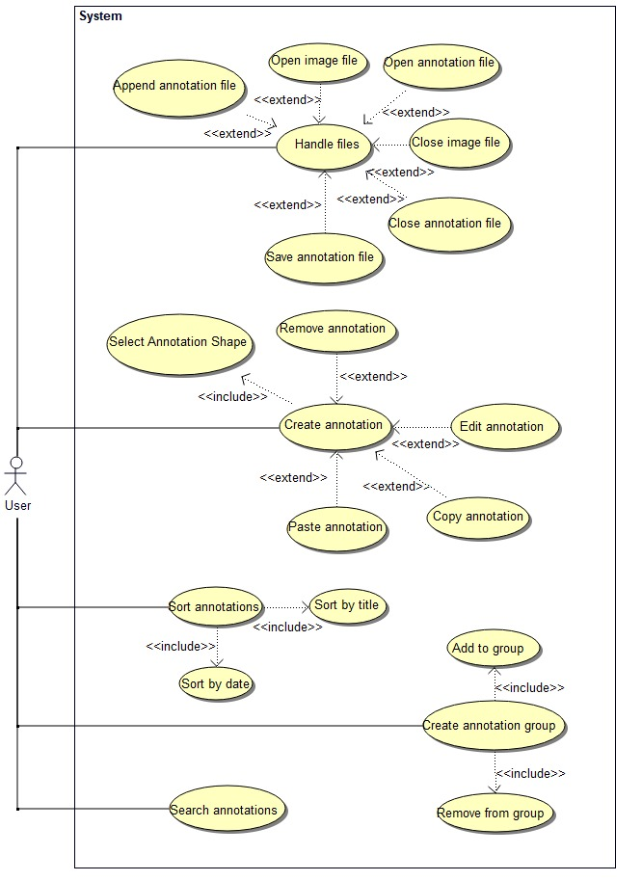
Figure 2 Use Case Diagram
In this use case diagram, the user is the sole actor; they are the only one that interacts directly with the program. The user can handle files, manipulate annotations, search annotations, and manipulate annotation groups as base functionality.
Handle Files allows the user to perform various types of file handling to be able to use the program. This extends to append annotation file, open image file, open annotation file, close image file, close annotation file, and save annotation file. <<extend>> is present because it is extended functionality of the base part (handling files).
Create annotation lets the user create an annotation. These annotations can also be removed, edited (resized or repositioned), copied, and pasted. Select annotation shape is included as this cannot be done without first creating the annotation. Create annotation extends to remove, edit, copy, and paste; these can in theory be done without creating an annotation and do not depend on the base use case.
Sort annotation allows for the sorting of annotations by title and date. Sort by title and sort by date depend on the base use case and cannot be done without the ability to sort in the first place.
Create annotation group allows the use to group annotations together. This includes add to group and remove from group, which are dependent on the base use case.
Search annotations lets a user search through the annotations.

Class Diagram

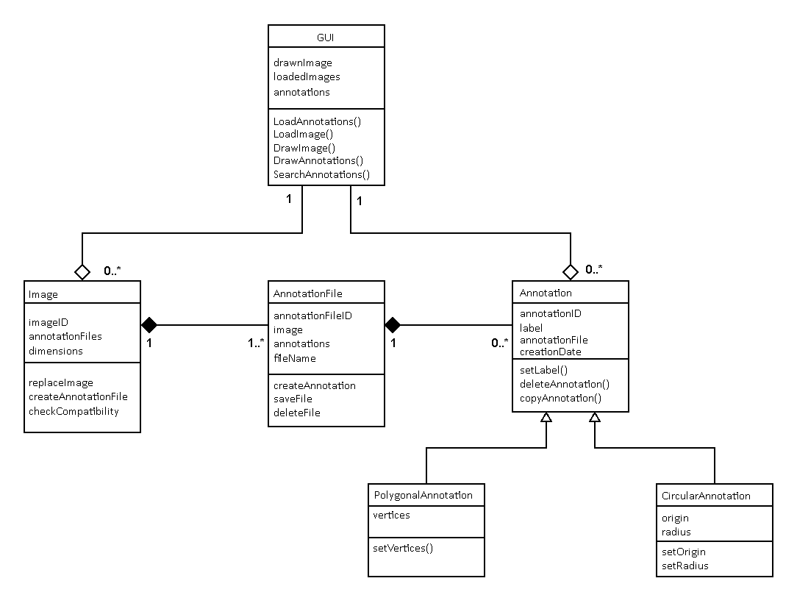
Figure 3 Class Diagram
This diagram consists of the key classes for the program, along with their respective attributes and operations.
The GUI represents the canvas on which images and annotations are displayed. Each instance of the program has one GUI, which has multiple images loaded and multiple annotations. The GUI has attributes for the image currently being drawn, any images that are loaded into memory, and annotations. From the GUI, the program may load images, annotations, and display them.
Each image has a unique ID to differentiate it from other images, a list of annotation files associated with that image, and the image size and dimensions. Operations include the ability to replace the image, check compatibility when the image is loaded, and create an annotation file to be associated with the image. An image may have multiple annotation files associated with it.
Annotation files have a unique ID, a relation to its associated image, and a list of annotations contained within the file. Its operations include creating annotations, saving the annotation file, and deleting the file. Each annotation file is only associated with one image but can be associated with many different annotations.
All types of annotation have a unique ID, a label (or name) describing the annotation in a string format, and the ID of the associated annotation file. With all annotations, the user may set and edit the label, copy and paste the annotation, or delete it. Each annotation is only associated with the one GUI, and one annotation file.
There are two subclasses of annotation: polygonal and circular. Polygonal annotations use a linked list of vertices which can be set in the relevant operation, while circular ones have an origin coordinate and radius, with operations that allow the user to define these.

Sequence Diagrams

In the program environment, the user is the only entity capable of interacting directly with the program. As such, they are the only actor in these sequence diagrams.
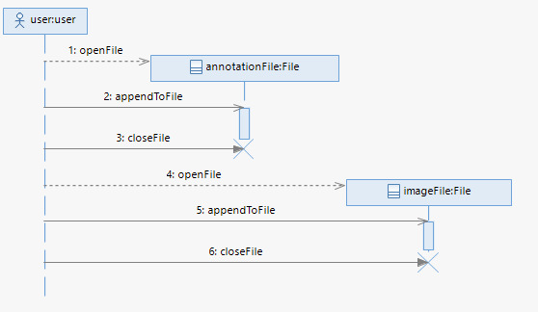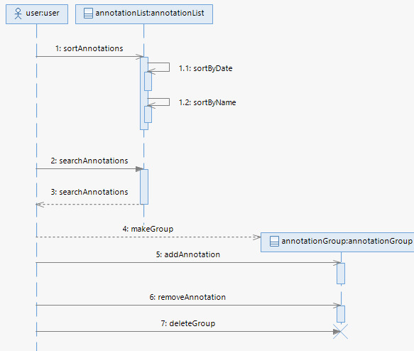
Figure 4 Sequence Diagram for file handling Figure 5 Sequence diagram for annotation file manipulation
Figure 3 demonstrates a user’s file handling ability for images and annotation files. The user first must open the relevant file; from here, they can make any amendments to the file (for example, in the image’s case, replacing the source file), before closing it again to prevent a memory leak.
Figure 4 shows the actions the user can perform on the annotation file. Users can sort through the existing annotations that are stored in a list. This list can be sorted by mot recent, oldest, A-Z or Z-A. The user would also be able to use a search box to find a particular annotation in the list. The user can further classify the annotations by creating or deleting group which they can add and remove annotations to.
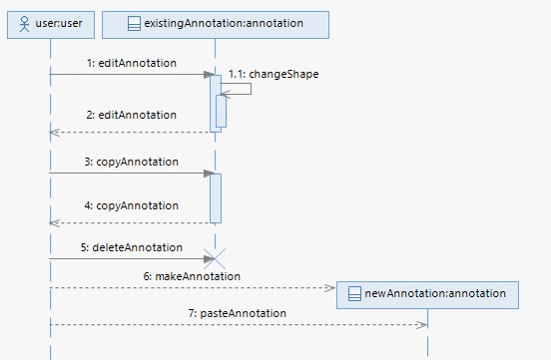
Figure 6 Sequence diagram for annotation manipulation
The sequence diagram in Figure 5 represents the process of editing an annotation. Users can edit any existing annotations (i.e. changing its shape or name) and can copy and paste these annotations as well as being able to delete them. When making a new annotation, the user can specify the type as well as the position and name of this annotation.

State Diagram

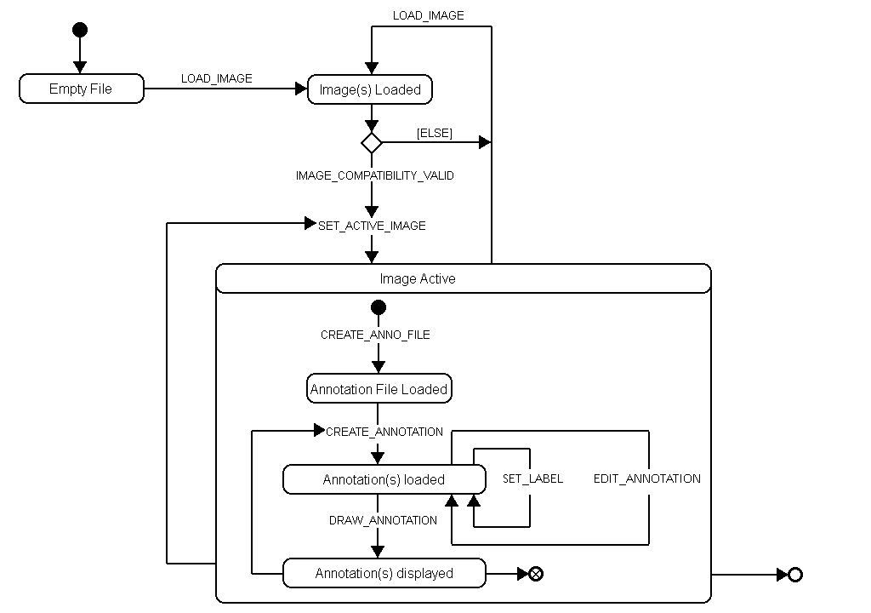
Figure 7 State Diagram
This state diagram demonstrates the process of starting the program, loading an image, and creating annotations. When the program is first started, the user must load an image. From here, the compatibility is checked; if it passes, the image may be set to active and displayed, otherwise the user must load a different image.
Within an active image, an annotation file can be created, with annotations either being loaded or created within the program. When an annotation is loaded, the label can be set/replaced and the annotation region itself may be modified. The user may swap the current active image or load new ones at any time. The final state is an image active in the interface, which may include annotation files and annotations.

Component Diagram

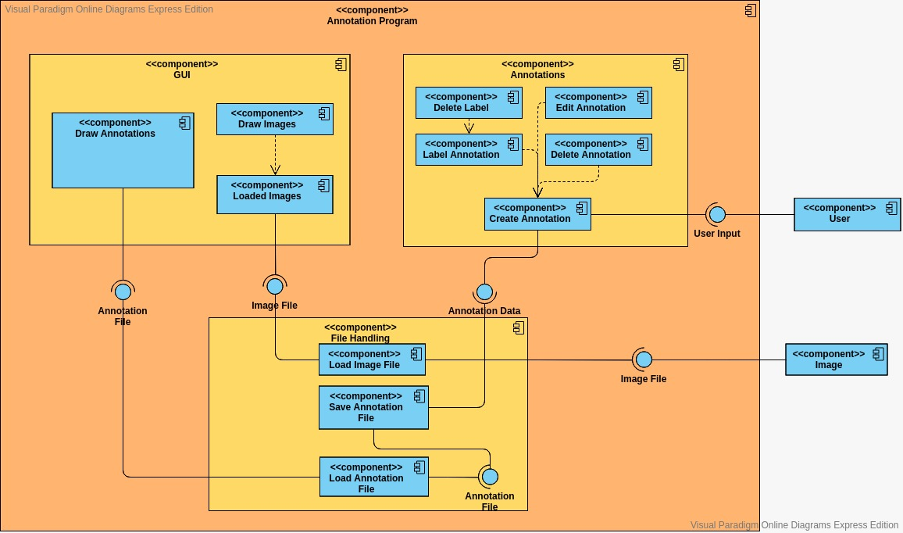
Figure 8 Component Diagram
A user provides the user input interface. This is then used by the annotations component to create an annotation. Delete annotation, edit annotation, label annotation, and delete label all depend on the create annotation function and therefore requires the user input interface. When an annotation is manipulated, annotation data is created as an interface.
This interface is used by the file handling component, which can then use that annotation data to save to an annotation file and produces an annotation file as an interface. The load annotation file component will then use that interface to load the annotation file. The load image file component then takes the image file interface provided by the image component and produces an image file to be loaded.
The GUI component uses both the annotation file and image file interfaces provided from the file handling component to load the image and annotation file to drawn them to the screen.

GUI Mock-up

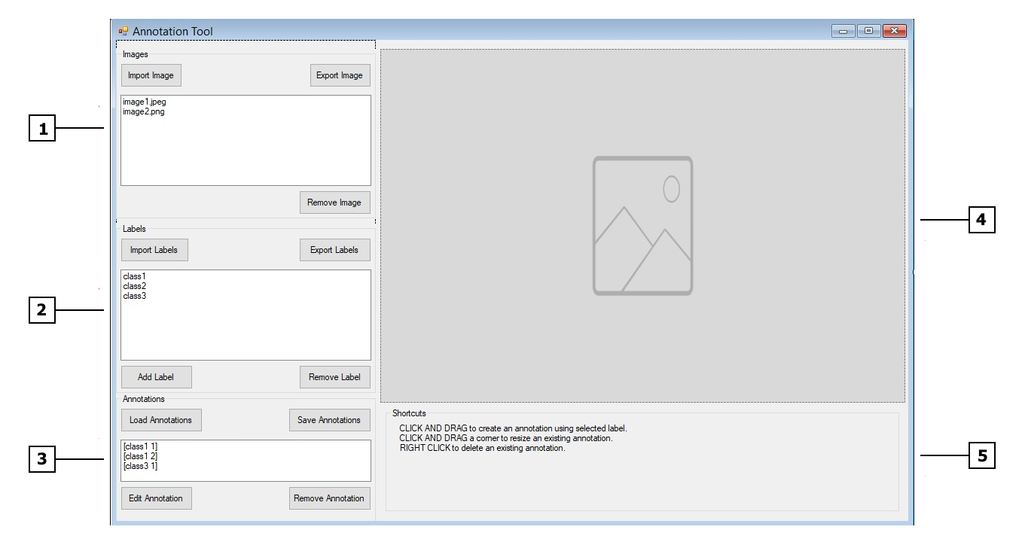
Figure 9 GUI Mock-up
Figure 8 shows a mock-up design of the User Interface for the program.
- Image List: A list of loaded images. Images can be imported, exported, and removed using the buttons located around the list. This can include .jpeg, .png, .bmp files.
- Label List: A list of labels included in the currently active image, with buttons which allow the user to import, export, create, and remove labels from a .names file.
- Annotation List: A list of annotations present in the currently active image. These annotations can be loaded from a file, saved to a file, edited, and removed using the buttons surrounding the list.
- Canvas: The area in which an image from the image list is displayed on-screen. This is where the user can create a manipulate annotations.
- Shortcut Information: Information is displayed at the bottom of the screen about command inputs the user can perform to create and edit annotations.
- Clicking and dragging a space on the canvas creates an annotation.
- Clicking and dragging the corner of an existing annotation resizes it.
- Right clicking an annotation deletes it.

Test Plan

All test scenarios will be defined using the following test table:

Table 5 - Sample Test Table
ID: |  | Description:
Test Type: |  | Success Criteria:
Number of Attempts: |  | Comments:
List of Equipment/requirements
Setup Instructions
Failure Correction Procedure
Engineer/Technician
Individual Results:
Screenshots

The tests will be a mixture of black box testing, white box testing, unit testing (found in the project’s source files), integration, and acceptance testing. All of these used in conjunction with each other will provide a much more robust product which will in theory meet the criteria defined by the client and provide a more user-friendly experience when interacting with the software. All test tables and scenarios can be found in Appendix 1.

Conclusions and Future Work

References

Hirose, A. (2013). Complex-Valued Neural Networks: Advances and Applications. Wiley-IEEE Press. [Accessed 20/04/2020]
Dybowski, R., & Gant, V. (Eds.). (2001). Clinical Applications of Artificial Neural Networks. Cambridge: Cambridge University Press. [Accessed 20/04/2020]

Individual Contributions Per Member

Richard Stone – Project Manager
- Overall report structure and piecing together
- Abstract
- Background Research
- Requirements Analysis
- Risk Assessment
- Time Plans
- Assumptions
- Coding Style Guide
- Use Case Diagram
- Component Diagram
- Conclusions and Future Work
Thomas Harrison – Software Architect
- Introduction
- Background Research
- Contribution Guide
- Class Diagram
- State Diagram
- GUI Mock-up
- Written aspect of the design
Samuel Harrison – Software Developer
- GUI Mock-up
- Entirety of development
- Doxygen
- Testing
Stephen Anderson – Software Tester
- Requirements Analysis
- Sequence Diagrams
- Test Plan
- Test Report
- Assisted with development

Overall Reflection of the Work Done

Overall, the group communicated well throughout the entire process of the project. For the first deliverable, the requirements and risks were very easily and readily identified by the group with very few issues. In the second deliverable, the tasks were divided equally amongst all members including UML diagrams and background research. For the third deliverable, a large amount of the development work had been achieved and achieved to a good standard.
The only deliverable which became problematic was the fourth deliverable, the software tester’s deliverable. The issues arose because the selected test framework (Boost) was designed for C++ code, which the group’s project was written in, however many of the libraries used (particularly the System library) were written with .NET code rather than C++, using CLI/CLR to bridge the gap between them and allow the .NET code to interact with the group’s C++ code. In this way, the test framework selected did not recognise the .NET code as it was designed to work solely on C++, and therefore created many issues in terms of unit testing. Despite this, the software tester and software developer created a solution by converting anything which uses System type data types into standard C++ types, which allowed the bulk of the unit testing to work, while other manual tests were created for the interface and front-end functionality.
Thus, although the fourth deliverable was by far the least straight forward, this was not through a lack of effort on any group member’s part, as the tester attempted to use five different frameworks before settling upon Microsoft Unit Testing Framework and the developer had to restructure a large proportion of the code. In future, this could have been potentially been mitigated with stronger research into which libraries and frameworks to use, however given the niche nature of this project this likely would have proven difficult.
In terms of the design phase, the software architect was instrumental in the creation and description of various UML diagrams and the GUI mock-up, while also helping strongly with the final report, while the project manager made sure to keep track of meetings and request frequent updates from each member while also contributing to every deliverable in some way and ensuring that workload was reasonably balanced.
Overall, despite the group running into many issues, through communication and strong effort the team overcame these problems and was able to achieve most of what was set out in the initial design phase.

Appendix

Appendix 1 – Test Report

Appendix 2 – User Interface

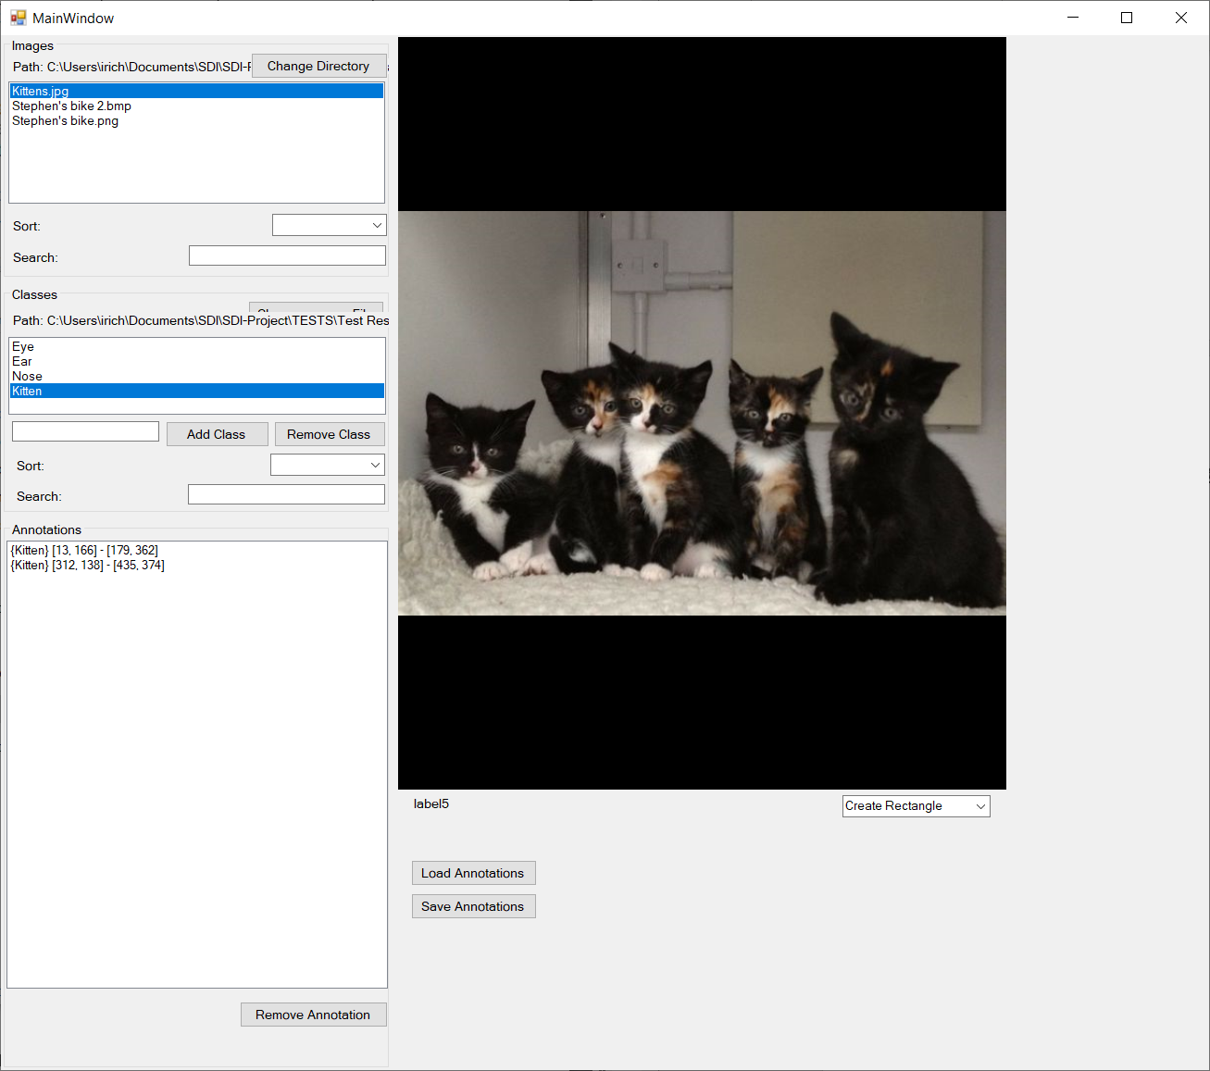
Figure 10 - Typical User Interface

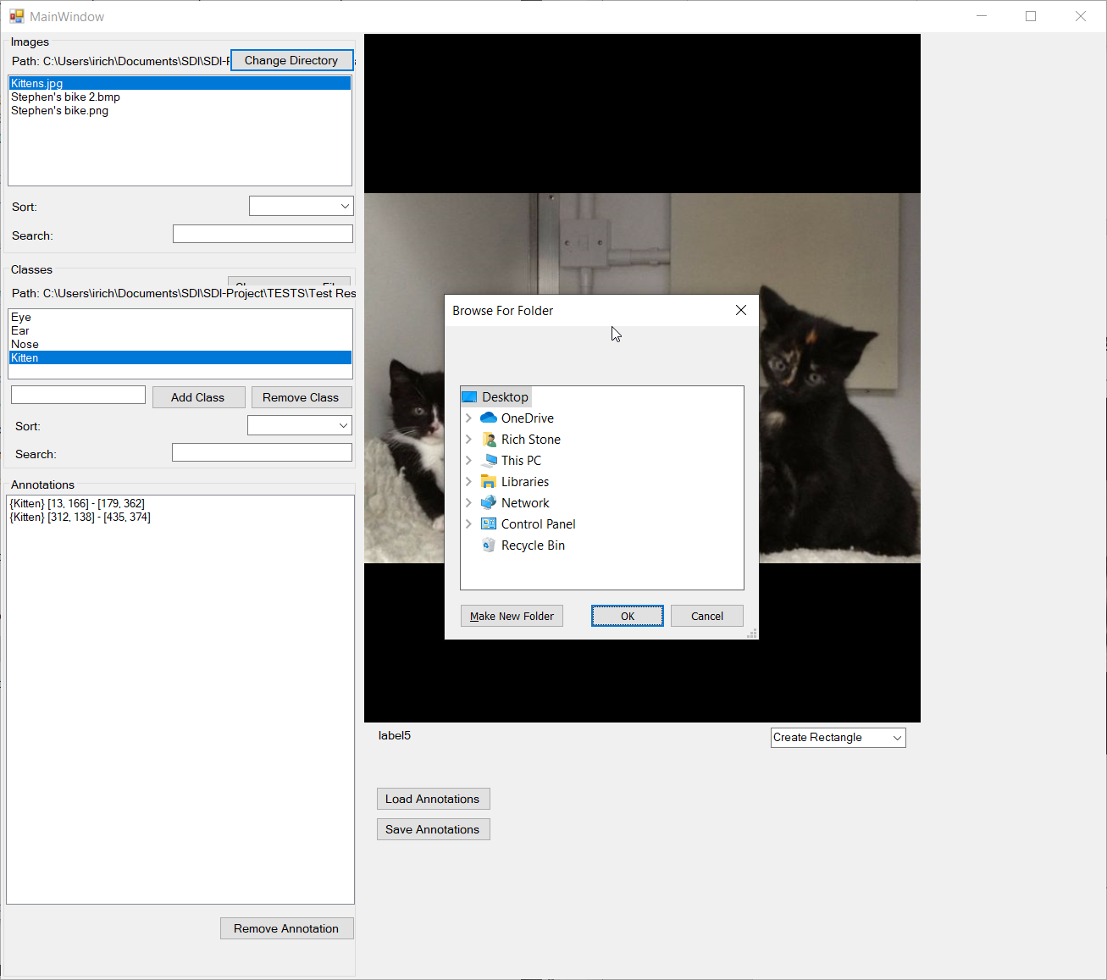
Figure 11 - Including File Browsing

Appendix 3 - Group Meetings

Meeting 1 – 13/1/20 Attended: All -Richard assigned design aspects to each member Richard: Use case, component Stephen: Sequence diagrams Thomas: State, Class Samuel: UI Design

Meeting 2 – 21/1/20 Attended: All
-Reviewed all diagrams up to this stage, decided to create the UI earlier in visual studio
-Assigned each member to write a description of their diagrams, and for Thomas Harrison to combine them and finish the other report aspects

Meeting 3 – 3/2/20 Attended: All
-Reviewed the final design document, all agreed upon
-Samuel demonstrated the current GUI that they created in visual studio
-Decided to wait to see what needed to be changed from the design to delegate jobs for implementation

Meeting 4 – 10/2/20 Attended: Richard Stone, Stephen Anderson, Samuel Harrison
-Began work on implementing code into the program and linking to the GUI -Samuel created implementation to load an image into the UI
-Richard decided that he will do the coding style guide, Thomas would do the contribution guide, and Stephen would work on creating the test plan.
-Time constraints were emphasized

Meeting 5 - 17/2/20 Attended: All
-Samuel showed that she was able to draw multiple images into the UI
-Showed that they could be grouped together with labels -Decided to begin work on creating full annotations
-Richard, Stephen, and Thomas said that they had all made progress on their respective documents from last meeting

Meeting 6 – 23/2/20 (Discord meeting) Attended: All
-Richard finished and showed coding style guide, had been agreed upon with Samuel but some code needed adapting
-Stephen produced test plan but stressed that boost had difficulty working with both the C++ and C# aspects of CLI, would continue to try and get it working. -
Agreed that Richard would create the video for the next deliverable.

Meeting 7 – 3/2/20 Attended: All
-Discussion following the most recent deliverable, decided that Thomas Harrison would need to work further on the contribution guide. -Samuel said they would continue working on the development, while Stephen would write tests when this had been delivered.

Meeting 8 – 30/3/20 (Emergency Discord meeting) Attended: All
-Discussion following most recent deliverable.
-Samuel Harrison would commit the code they have to the git regardless of the state of the code.
-Stephen Anderson would take a shared role with Samuel Harrison and become more heavily involved in development. Stephen Anderson and Richard Stone will then write the test cases together. Thomas Harrison will help where needed, in either development or testing.
-This will be completed within the next few days, Thursday at the latest.

Plagiarism Declaration

This report and the software it documents is the result of my own work, other contributing group members are acknowledged. Any contributions to the work by third parties, other than tutors, are stated clearly below this declaration. Should this statement prove to be untrue I recognise the right and duty of the Board of Examiners to take appropriate action in line with the university’s regulations on assessment.

Name: Richard Stone
ID No: N0782914

Name: Stephen Anderson
ID No: N078602

Name: Samuel Harrison
ID No: N0787108
Name: Thomas Harrison
ID No: N0833220

